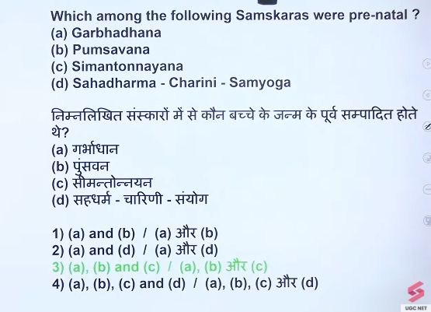
1 SGP

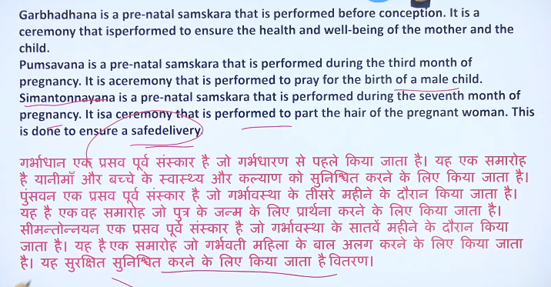

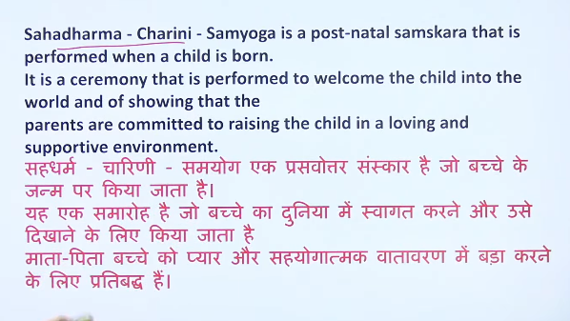

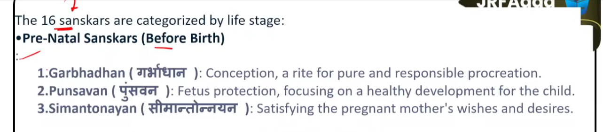

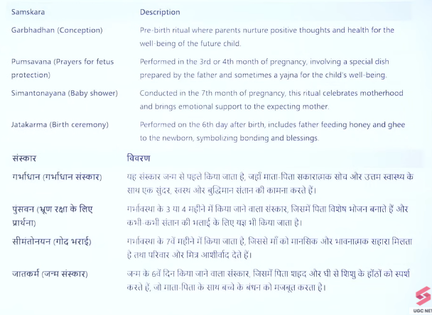

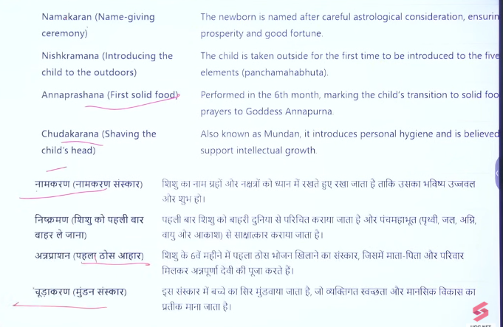
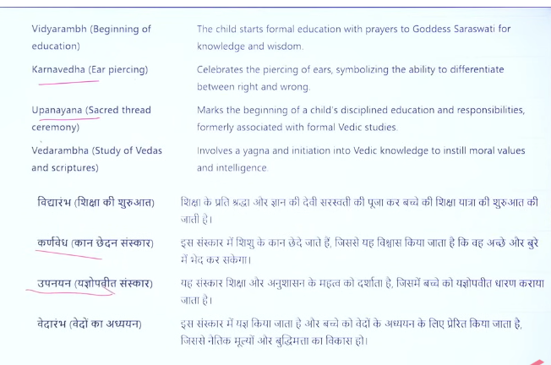

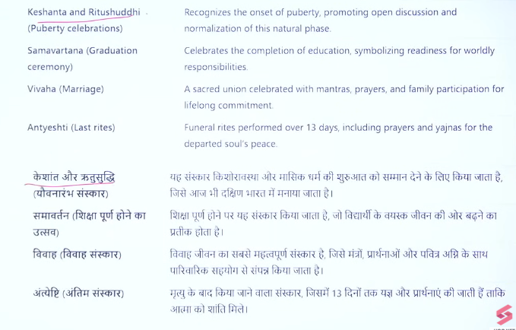

2
ANS:b
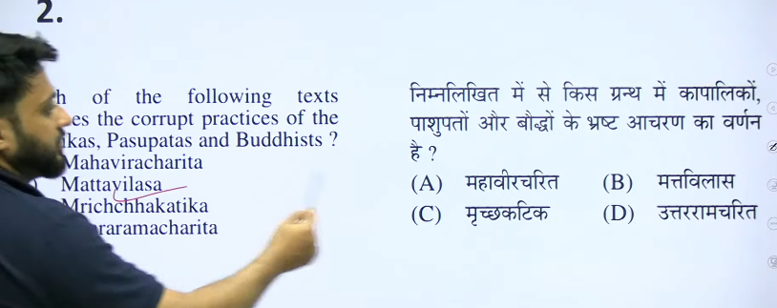

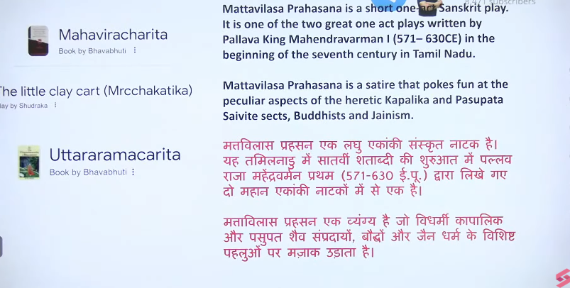

3
Ans: d
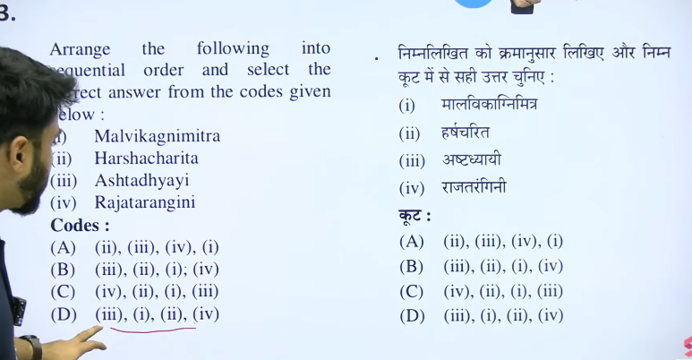
12th CE
7th CE
5th CE
6th - 5th BCE
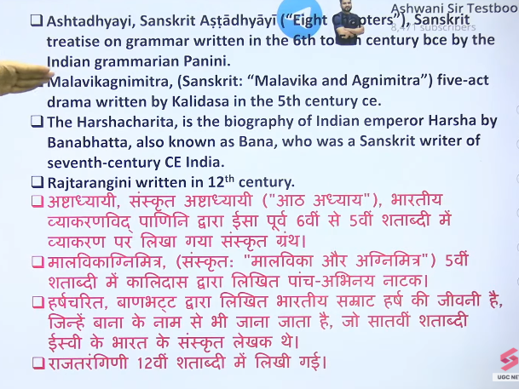
📖 Basic Info
- Written by: Panini
- Time: around 5th–4th century BCE
- Region: Gandhara (North-West India)

👑 King ka naam?
👉 Direct kisi specific king ka naam mention nahi hai
❌ Yeh kisi king ke liye likhi gayi book nahi thi
👉 Yeh ek grammar (vyakaran) ki kitab hai
- Sanskrit language ke rules batati hai

🧠 Important UPSC Point
👉 Isme janapadas, cities, social life ka indirect mention milta hai
👉 Par focus language rules par hai, na ki kings par

📌 One-line:
👉 “Ashtadhyayi by Panini (5th–4th century BCE) is a Sanskrit grammar text, not related to any specific king.”

Agar chaho to main iska UPSC me kaise question aata hai bhi bata deta hoon 👍
Panini's Ashtadhyayi was written in the 6th to 4th century BCE (commonly cited as around 500 BCE or the late 4th century BC), making it an ancient Sanskrit treatise on grammar. Written in India (modern-day Pakistan), this foundational text contains over 4,000 rules that established the standard for classical Sanskrit.
- Period: Mostly dated to the 6th–5th century BCE, with some studies focusing on the 4th century BCE.
- Significance: It is the oldest complete linguistics text, often described as a "language machine" for producing grammatically correct Sanskrit sentences.
- Structure: Ashtadhyayi translates to "Eight Chapters," containing over 4,000 sutras.
It was compiled to document and preserve the formal structure of Sanskrit language, bridging the gap between earlier Vedic language and contemporary usage
.

Mālavikāgnimitram (Malavikagnimitra) was written by the poet Kalidasa in the 5th century CE.
Key details regarding the text:
- Time Period: It is believed to have been composed during the Gupta Period (4th–5th century CE), often described as the "Golden Age" of classical Sanskrit literature.
- Context: It is recognized as one of Kalidasa's earliest works.
- Theme: It is a five-act Sanskrit drama that tells the love story of King Agnimitra (son of Pushyamitra Shunga) and a maid named Malavika.
Agnimitra Shunga, the second emperor of the Shunga dynasty, reigned from approximately 149–141 BCE. He succeeded his father, Pushyamitra Shunga, and ruled for about 8 years, during which he maintained control over northern and central India. He is also the hero of Kalidasa’s drama, Malavikagnimitram.
Key Details of Agnimitra's Rule:
- Reign Duration: ~149–141 BCE, succeeding his father Pushyamitra.
- Reign Length: The Vayu and Brahmanda Puranas assign a 8-year reign to him.
- Territory: He operated from Vidisha (or Magadha) and expanded the empire towards the Narmada region.
- Key Events: Known for conducting a campaign against Vidarbha and being the hero of the classical Sanskrit play Malavikagnimitram.
- Succession: He was succeeded by his son, Vasumitra.
Agnimitra was part of the 112-year rule of the Shunga Dynasty (~185-73 BC

Kalhana wrote the Rajatarangini between 1148 and 1150 CE during the reign of King Jayasimha (1127–1155 CE) of Kashmir. The 12th-century Sanskrit chronicle, which documents the history of Kashmiri kings, was completed in the 22nd year of Jayasimha’s reign, providing a detailed, critical history.
Testbook +3
Key Details About the Text:
- Author: Kalhana, a Kashmiri Brahmin.
- Time Period: 12th Century CE (finished around 1150 AC).
- Subject: Historical chronicle of Kashmir.
- Significance: Known as the first genuine, scientific historical text in India, which separates fact from myth
.

Testbook +3
Kalhana's father, Champaka, was a minister under an earlier ruler, King Harsha, which provided Kalhana with a
Rajatarangini, the comprehensive history of Kashmiri kings, was written by the poet and historian Kalhana in the 12th century CE. Composed in Sanskrit between 1148 and 1150 CE, this chronicle contains 7,826 verses divided into eight books, known as Tarangas.
Wikipedia +3
Key Details of Rajatarangini:
- Author: Kalhana.
- Time Period: Mid-12th century (c. 1148–1150 CE).
- Language: Sanskrit.
- Content: A chronological account of the kings of Kashmir, noted for its detailed historical and cultural information
.
- Significance: It is often regarded as the first well-researched work of history from ancient India.
Rajatarangini (The River of Kings), written in Sanskrit by the 12th-century historian Kalhana, provides a detailed, continuous history of the kingdom of Kashmir.
Wikipedia +1
Key details about the text include:
- Coverage: It covers the history of Kashmir from its earliest origins, including legends, up to the 12th century CE, concluding during the reign of King Jayasimha (1128–1149 CE).
- Dynasties: The work chronicles several Kashmiri dynasties, including the Gonandiyas, Karkotas, Utpalas, and Loharas.
- Historical Method: Kalhana utilized a variety of sources, including royal records, inscriptions, earlier chronicles (such as Nilamata Purana), and family records to ensure accuracy, making it one of the most reliable historical texts from ancient/early medieval India.
- Significance: It is regarded as the earliest sustained regional history in India, with its name translating to "The River of Kings"
📖 Rajatarangini
- Written by: Kalhana (12th century)
- Meaning: “River of Kings”
- Region: Kashmir

📌 Key Features
- Kashmir ke rajaon ka chronological history
- Mythological se lekar 12th century CE tak
- Ends with: Jayasimha (1128–1155 CE)
- Divided into 8 Tarangas (books)
- Sources: earlier texts, inscriptions, coins

👑 Important Dynasties/Names
- Gonanda dynasty
- Maurya (Ashoka)
- Kushan (Kanishka)
- Huna (Mihirakula)
- Karkota (Lalitaditya)
- Utpala (Avantivarman)
- Lohara (Queen Didda)

🧠 Importance (UPSC)
👉 India ki pehli historical chronicle jisme systematic history likhne ki koshish hui

📌 One-line:
👉 “Rajatarangini by Kalhana is a 12th-century chronicle of Kashmir kings arranged in chronological order.”
river of kings why i dont udnerstood
Achha question 👍 “River of Kings” thoda confusing lagta hai, simple example se samajhte hain 👇
📖 Rajatarangini ka meaning
👉 “Rajatarangini” =
- Raja (king) + Tarangini (waves/river)

🧠 Simple samajh:
👉 Jaise nadi (river) mein pani lagataar behte rehta hai
👉 Waise hi ek ke baad ek raja aate gaye
✔ Ek king gaya → doosra aaya → fir teesra…
👉 Bilkul river ke flow ki tarah

🎯 Isliye naam diya:
👉 “River of Kings” = Rajaon ka lagataar flow (series)

📌 One-line:
👉 “River of Kings ka matlab hai rajaon ki continuous series, jaise nadi ka flow.”

Agar chaho to main iska ek visual diagram (river flow style) bana ke aur clear kar deta hoon 👍
Haan 👍 bilkul sahi samjhe tum
👉 “River of Kings” = Kings ki chronology (sequence)
📌 Simple line:
👉 Rajatarangini = Kashmir ke rajaon ki chronological list/story

🧠 Aur easy:
👉 Kaun pehle raja tha → uske baad kaun → fir kaun
👉 Matlab time ke order me kings ka record

🎯 Final UPSC understanding:
👉 “Rajatarangini presents a chronological account of kings of Kashmir.”
4
Ans: a
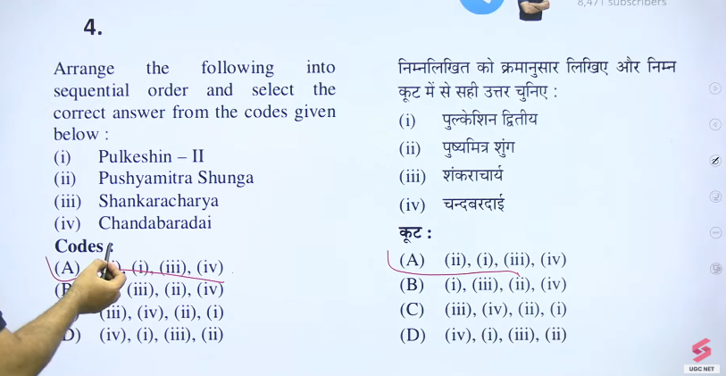
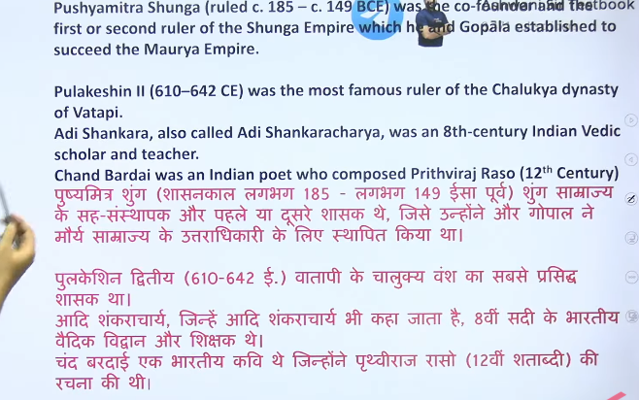
Ashoka delay cornation due to war against the brother

6
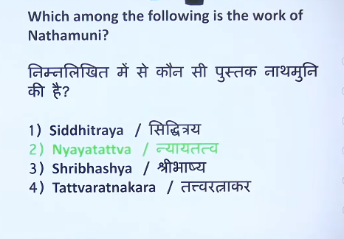
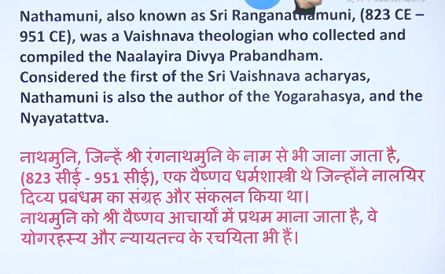
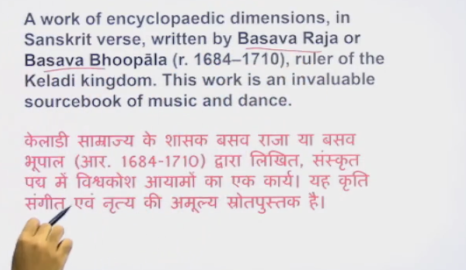
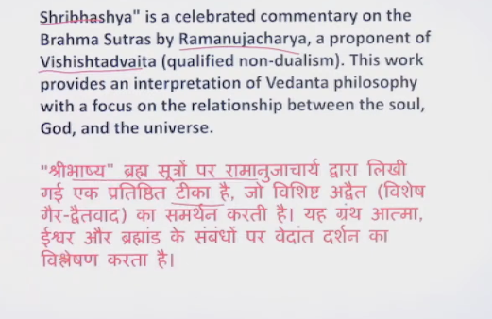
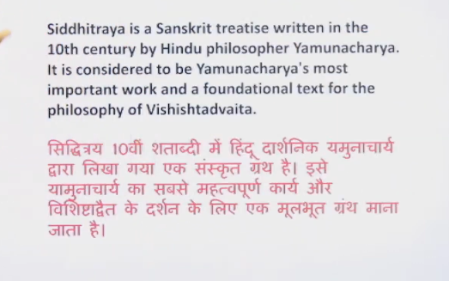

8
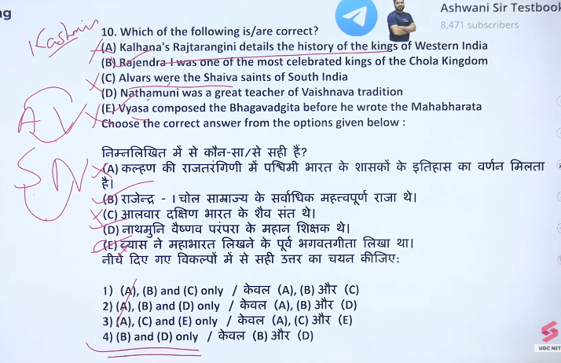

10 Ans: C
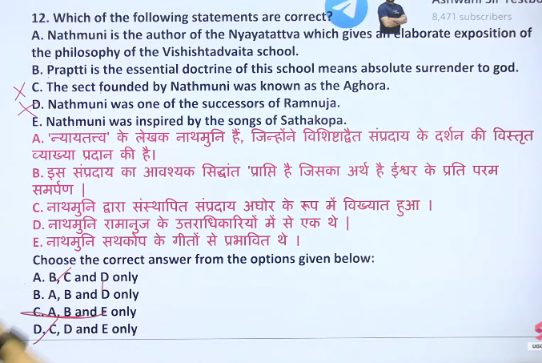

Both Nathamuni and Ramanujacharya are South Indian philosophers and acharyas of the Sri Vaishnava tradition.
It is actually the opposite: Nathamuni (c. 823–951 CE) was a predecessor of Ramanujacharya (1017–1137 CE).
Here is the correct context of their relationship and roles in the Sri Vaishnava tradition:
- Nathamuni (The First Acharya): Nathamuni is regarded as the Prathama Acharya (first acharya) who revived the Divya Prabandham (4,000 Tamil hymns of the Alvars) and established the Visistadvaita tradition, setting it on a new path.
- Yamunacharya (The Bridge): Nathamuni's grandson was Yamunacharya (Alavandar), who was a major scholarly successor to Nathamuni.
- Ramanujacharya (The Successor): Ramanuja is considered the spiritual successor and inheritor of the tradition perfected by Nathamuni and Yamunacharya. Ramanuja followed in their footsteps and solidified the Visistadvaita philosophy.
- Lineage Sequence: The standard lineage, or Guru-paramparā, begins with Lord Narayana, then Nathamuni, then Yamunacharya, and finally Ramanuja.
In summary, Nathamuni and his grandson Yamunacharya were pioneers who laid the philosophical and devotional foundation that Ramanuja later inherited, fortified, and spread.

Sriman Nathamuni (10th century CE) is revered as the first Acharya of the Sri Vaishnava tradition, serving as the bridge between the Tamil Alvars' bhakti tradition and the Sanskrit Vedic tradition. While he is commonly associated with reviving the Naalayira Divya Prabandham (the 4000 hymns of the Alvars), his philosophical foundation is rooted in Vishishtadvaita (Qualified Non-dualism), a precursor to the systemic theology later popularized by his grand-disciple, Ramanuja.
Here is an overview of Nathamuni's role and the philosophical tradition he helped establish:
1. Nathamuni's Role and Contribution
- Founder of Sri Vaishnava Tradition: Nathamuni is recognized as the first acharya of the Sri Vaishnava sampradaya.
- Revival of Tamil Scriptures: He revived the Tamil Naalayira Divya Prabandham, which had been lost, and introduced the practice of singing them in temples (araaiyar sevai).
- Bridge between Sanskrit & Tamil: He united the Vedic (Sanskrit) tradition with the Bhakti (Tamil) tradition, treating them as equally authoritative, a "twofold scripture" approach.
- Key Works: He authored Nyaya-tattva and Yoga-rahasyam, which provided the foundational philosophical structure for Vishishtadvaita Vedanta.
2. Core Philosophy: Vishishtadvaita (Qualified Non-Dualism)
Nathamuni laid the groundwork for Vishishtadvaita, which holds the following principles:
- Brahman as Supreme: The Supreme Reality (Brahman) is personal and identified as Vishnu/Narayana, possessing infinite, auspicious qualities (Saguna Brahman).
- Qualified Unity: While Advaita posits "only one," Nathamuni's Vishishtadvaita proposes that the world (Jagat) and individual souls (Jivas) are distinct but real parts of the whole, constituting the "body" of Brahman.
- Relationship of Dependency: The individual soul (Jiva) is distinct from the Supreme God (Vishnu) but is eternally dependent on Him.
- Bhakti as Means of Salvation: Liberation (moksha) is achieved through bhakti (devotion) and prapatti (total surrender) rather than just knowledge (jnana).
3. Key Distinctions
- Vishishtadvaita vs. Advaita: Unlike Shankaracharya's Advaita (absolute non-dualism), Nathamuni’s school argues that diversity is real and that the soul retains its identity even after salvation.
- Precursor to Ramanuja: Nathamuni lived before Ramanuja (1077–1157), and his work set the theological stage for Ramanuja's formalization of the Visishtadvaita school.
Nathamuni's philosophy brought together the intellectual rigor of Sanskrit philosophical tradition and the emotional intensity of the Tamil Alvars, establishing a unique tradition that remains influential today.

Nathamuni and Ramanujacharya are key figures in the Sri Vaishnava tradition, with their relationship being primarily spiritual and lineage-based (Guru-Parampara) rather than a direct personal acquaintance. Nathamuni (approx. 9th–10th century) is considered the first major Acharya who revived the tradition, while Ramanujacharya (approx. 11th–12th century) is the main proponent of the Vishishtadvaita philosophy.
Key details regarding their connection:
- Lineage Connection: Nathamuni is the grandfather of Yamunacharya (Alavandar), who is one of the five Acharyas of Sri Ramanujacharya.
- Philosophical Grandfather: Nathamuni is often regarded as the "philosophical grandfather" of Ramanuja, as he laid the foundation for the Visistadvaita philosophy that Ramanuja later established, structured, and spread.
- The "Nathamuni" Promise: Tradition states that Nathamuni (and later his grandson Yamunacharya) had a vision or knowledge that a great reformer (Ramanuja) would come to sustain the Sampradaya.
- Spiritual Continuity: Nathamuni compiled the 4,000 Divya Prabandham (hymns of the Alvars), which are the core devotional texts used by Ramanuja in his teachings.
- Guru-Parampara Structure: In the lineage list starting from Vishnu, Nathamuni is listed early on as Natha and Ramanuja as a later, crucial preceptor in the Guru-paramparam.

11
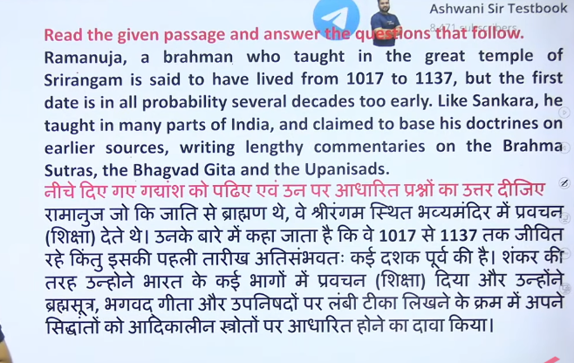

12
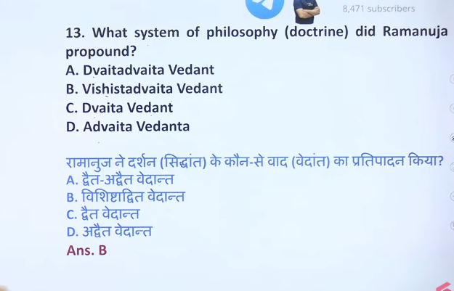
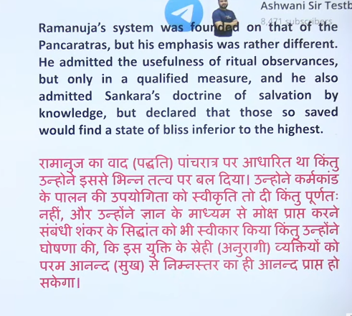

AI Overview
Ramanujacharya
is generally recognized as the primary proponent and philosopher who codified and systemized the Vishishtadvaita philosophy.
While Nathamuni is recognized as a pioneering saint (Acharya) who revived the Sri Vaishnava tradition and established the foundation of the philosophy in the 10th century, and Yamunacharya (his grandson) wrote early treatises, it was Ramanujacharya (11th–12th century) who wrote the definitive commentaries—most notably the Sri Bhasya—that established Vishishtadvaita (qualified non-dualism) as a distinct Vedanta school.
Key Details:
- Founder/Systemizer: Ramanujacharya.
- Key Contributions: Ramanuja wrote Sri Bhasya (commentary on Brahma Sutras) and Vedarthasamgraha (treatise on Upanishads).
- Predecessors: Nathamuni and Yamunacharya paved the way, but did not write the systematized commentaries.

Nathamuni (c. 9th–10th century CE) was the first major Acharya of the Sri Vaishnava tradition and the foundational teacher/preceptor for Ramanujacharya (11th–12th century), though not his direct contemporary teacher. He is considered Ramanuja's "philosophical grandfather," as Nathamuni's grandson, Yamunacharya, was the direct mentor to those who taught Ramanuja
Ramanujacharya (11th–12th century) is the primary founder and leading exponent of the Vishishtadvaita (qualified non-dualism) school of Vedanta philosophy. He formalized this philosophy, which emphasizes bhakti (devotion) to Vishnu, holding that individual souls and the material world exist as distinct parts of a single, ultimate reality (Brahman).
Key Details About Ramanujacharya and Vishishtadvaita:
- Core Philosophy: Vishishtadvaita means "non-dualism with differentiation," teaching that Brahman (Vishnu) is the supreme reality, and the universe/souls are part of His nature, rather than a mere illusion.
- Key Contributions: Ramanuja authored crucial texts like Sri Bhashya (a commentary on the Brahma Sutras) and Vedartha Samgraha.
- Social Impact: Known as Emperumanar, he was a social reformer who championed temple access for all, promoting bhakti and equality.
- Origins: While Ramanujacharya is the main founder, he based his teachings on earlier thinkers like Bodhayana.
- Legacy: His teachings laid the foundation for the Sri Vaishnavism tradition and greatly influenced the Bhakti moveme

13
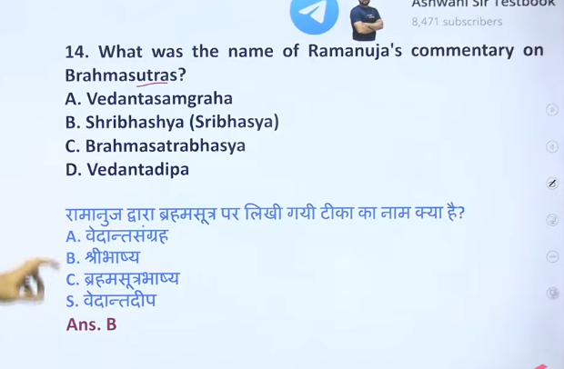
14
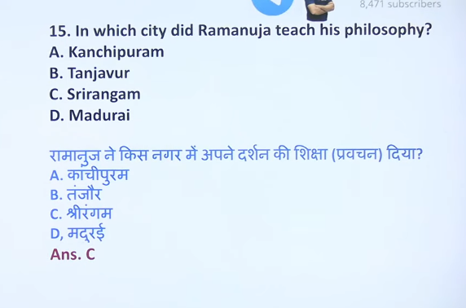

15
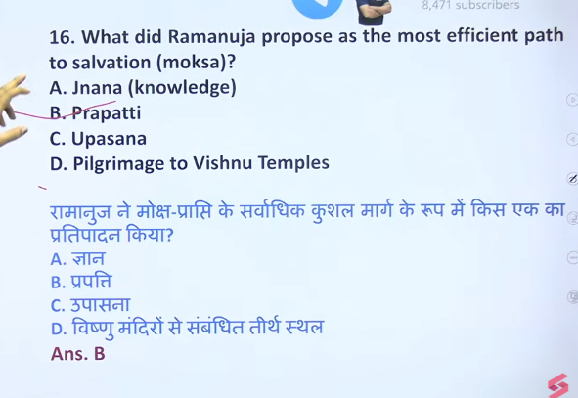

16
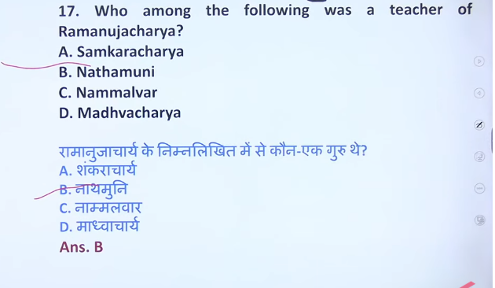

17
